To earn full weekly discussion credit, students are expected to comment on all prompts posed by the instructor and provide responses to classmates. Each Discussion Board post will be assessed using a rubric (under the My Grades menu item). In addition to reviewing the grading criteria in the rubric, please note the following expectations for Discussion Board posts:
- Discussion posts must be completed during the week they are assigned. Discussion posts made in advance of the assigned week will not count toward your grade. If you wish to work ahead, please compose your responses in a Word document, then post when the week arrives.
- Each week, you are required to submit a reply to each initial prompt and replies to your peers or instructors in the Discussion Board. The required posts are as follows:
- Any post made in the Discussion Board must be well-developed.
  - A well-developed post is meaningful, shows relevance to the topic, and reflects your knowledge of the material. Well-developed posts demonstrate synthesis of the subject matter, extend the discussion by building on previous posts, and include proper source citations, when applicable. Posts limited to "I agree," "Great posting," or "Thank you" will not be assessed as well-developed, and will therefore not be considered a contribution to the number of required weekly posts.

Week 1 Discussion

Discussion Prompt
COLLAPSE

Describe one situation you have encountered where your actions were guided by the Nursing Code of Ethics. If you have never encountered such a situation, imagine a possible situation you could face in the future. Link this experience to one of the elements in the code of ethics found athttp://www.nursingworld.org/codeofethics.

WEEK 2

- Nurses use evidence based practices in making clinical decisions. A good example of this is hand hygiene to prevent the spread of infection. How else does a registered nurse use guided research in the clinical setting?

- Explore your clinical site and relate one quality improvement (QI) study currently being analyzed. What is benchmarked in the study? What role does the nurse play in the QI study?

WEEK 3
- What stood out to you after exploring the Sigma Theta Tau website?

- Do you describe yourself as a lifelong learner? If so, why do you feel it is important?

Week 4
- As a professional nurse, what are some ways in which you are able to reach out to members of the community who do not have access to healthcare reform?

- Does equating status with authority cause confusion? Why or why not?

Week 5

- How do you feel about the MDG initiatives? Discuss ways a community nurse can help with the goals.
- Many resources are spent on recruiting foreign nurses. It is a fast-growing private sector business. If the United States and other industrial nations put their resources into fixing the problems that lead to this shortage of nurses, would the need to recruit foreign nurses decrease? Why or why not?

Week 6
- What does professional commitment mean to you? Give an example.
- Do you believe that nurses as lobbyists are essential to the growth of nursing as a profession? Why or why not?
Week 7 1. Do you feel that nurses believe that there are ethical concerns related to nursing informatics?

2.Discuss how the use of health information (HI) technology has influenced your current nursing practice. Give examples.

Week 8
1. Do you feel socializing with your colleagues is beneficial in creating a better learning environment? Why or why not?
- What are some key elements in motivating clients to improve health behaviors and outcomes? What role does the family play?

Week 9

Write a summary of your current trend/issue paper for your classmates. Explain why you chose your topic, its current relevance, and the research you found regarding it.

Please do APA format, with in text citations and references

Week 5: Patient Safety Culture Pamphlet
Create a pamphlet using any type of publisher software you choose to educate clients on a current patient safety issue; for example, a currently aging adult and how to care for his/herself at home, medication-polypharmacy and how a patient can not make a self medication error, or other appropriate safety issues. If you have a question about a specific topic, check with your instructor.
Your pamphlet must include the following items:
- Include at least 5 tips for preventive care for the patient.
- Include information that should be shared with family or caregivers.
- Include local resources in the community that might be available for this type of safety concern.
- Include at least 3 current (published less than 5 years ago) references, in APA format.
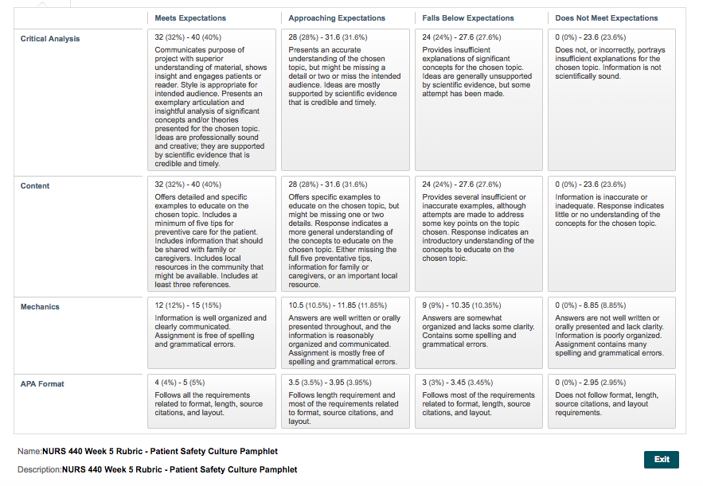

Week 7: Intelligent Hospital Pavilion ICU Video Analysis/Reflection
Review the Intelligent Hospital Pavilion ICU video at https://youtu.be/V42yuH4xmyQ. Write a paper in which you identify and describe elements that you feel are of benefit or risk to both patients and nurses. Explain the benefits/risks and why you do or do not support this type of available technology. Your paper should be a minimum of three pages and written in APA format with at least two outside credible references.
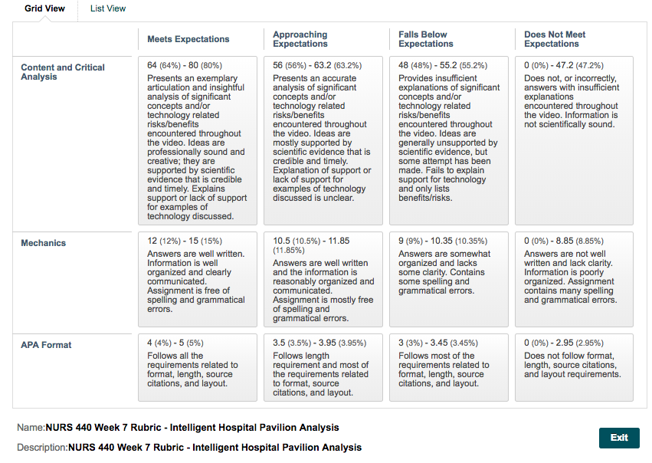

Week 9: Current Issue/Trend Paper

Choose a current issue/trend topic from the following list:
  - Technology in health care
  - Collective bargaining
  - The impaired nurse- choose this one if you want
  - The global nurse workforce
  - Mentoring and coaching in nursing
  - The trimodal model of 21st-century effective nurse leaders
  - Other instructor-approved topic

Create a 6- to 8-page paper in APA format including a minimum of 4 to 5 references. Explain how you would lobby your legislators or local government for funds to support your issue or trend. Include the following elements in your paper: share why you chose the specific topic, the current relevance of material, how it is integrated into clinical practice, and how the information is used in clinical setting.
